**Manual for Setup Image Processing using Pyton, YOLOv5**

**Section A: Initial step for basic image processin…..**

**Section B: Training Image…**

**Section C:**

**Section A: Set up YOLOv5**

**YOLOv5 Custom Object Detection**

1. Follow this link: [https://wandb.ai/onlineinference/YOLO/reports/YOLOv5-Object-Detection-Tutorial-Bounding-Box-Webcams-For-Zoom--VmlldzozMDEzNDM5 to set up YOLOv5](https://wandb.ai/onlineinference/YOLO/reports/YOLOv5-Object-Detection-Tutorial-Bounding-Box-Webcams-For-Zoom--VmlldzozMDEzNDM5%20to%20set%20up%20YOLOv5).
2. Download anaconda prompt at <https://www.anaconda.com/download>

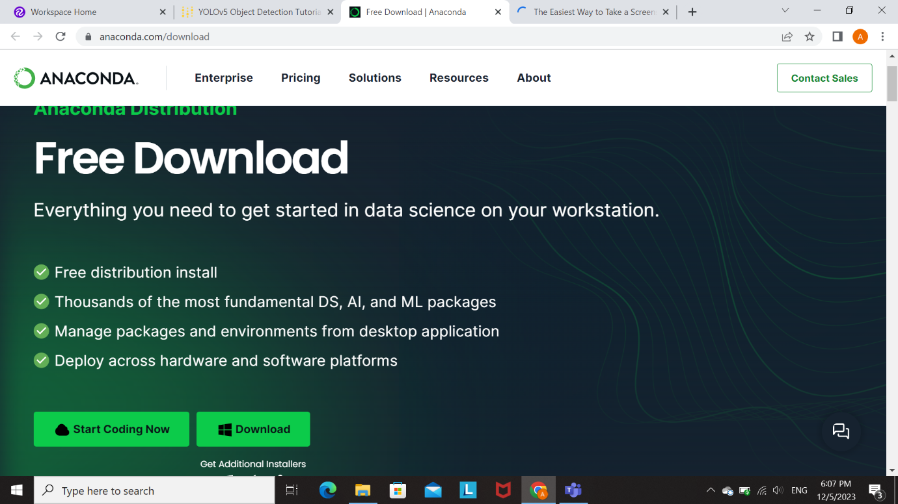

1. Download zip files of yolov5 from their github: <https://github.com/ultralytics/yolov5>

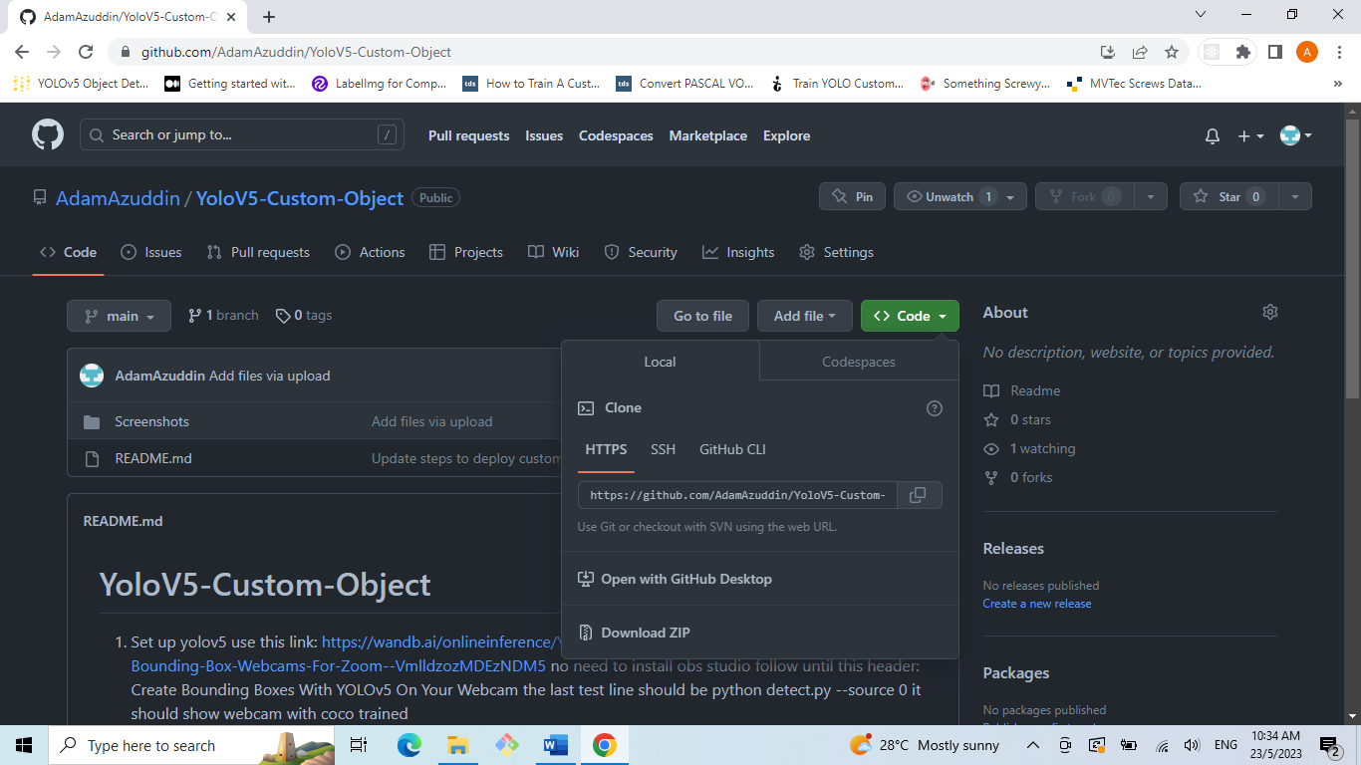

1. Create a new folder at C:/Owner/New_Folder (Rename the New_folder to Projects to follow along this tutorial)
2. Unzip the downloaded zip from github into the new Projects folder
3. Open downloaded anaconda file and follow through the installation step to install it. Just click through all the default options

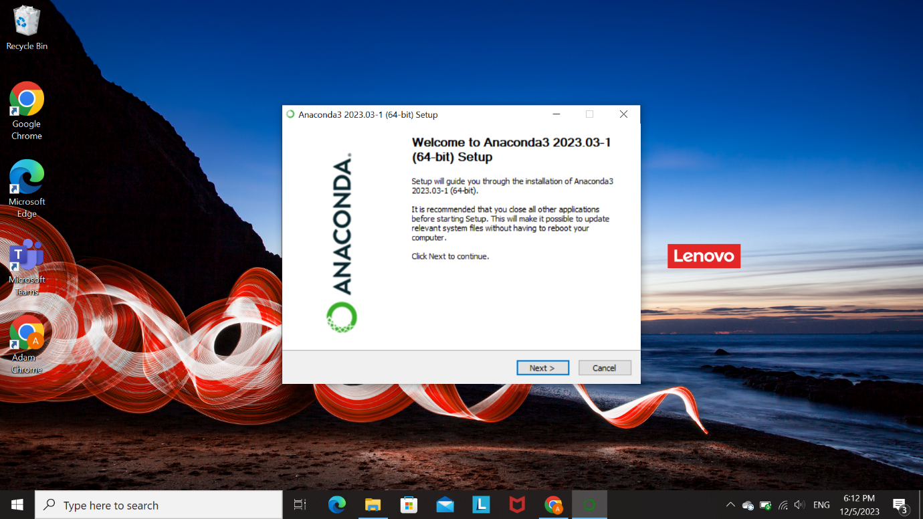

1. Open anaconda prompt

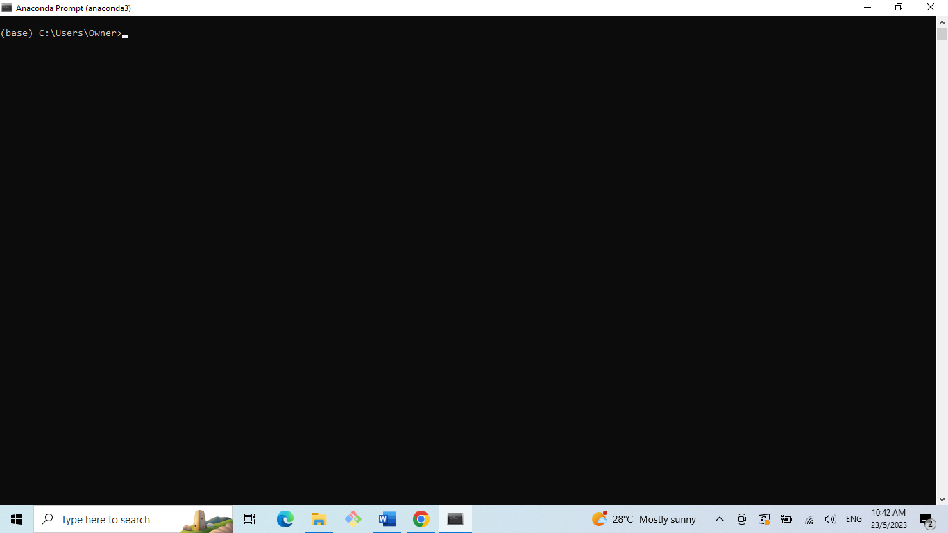

1. Navigate to yolov5 folder by entering cd Projects/yolov5

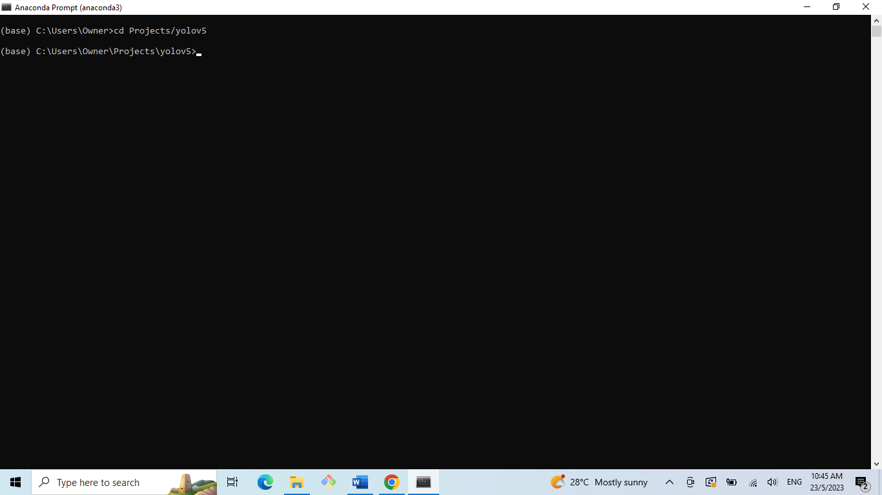

1. Create a new conda environment by typing conda create –name Yolov5 python=3.9

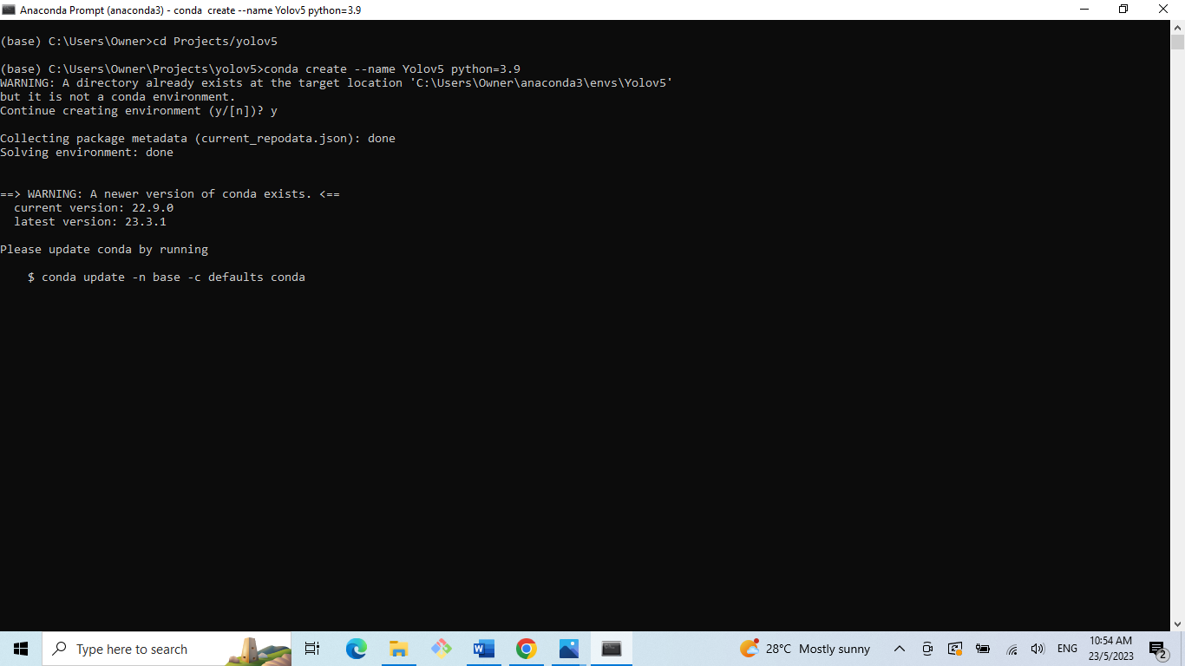

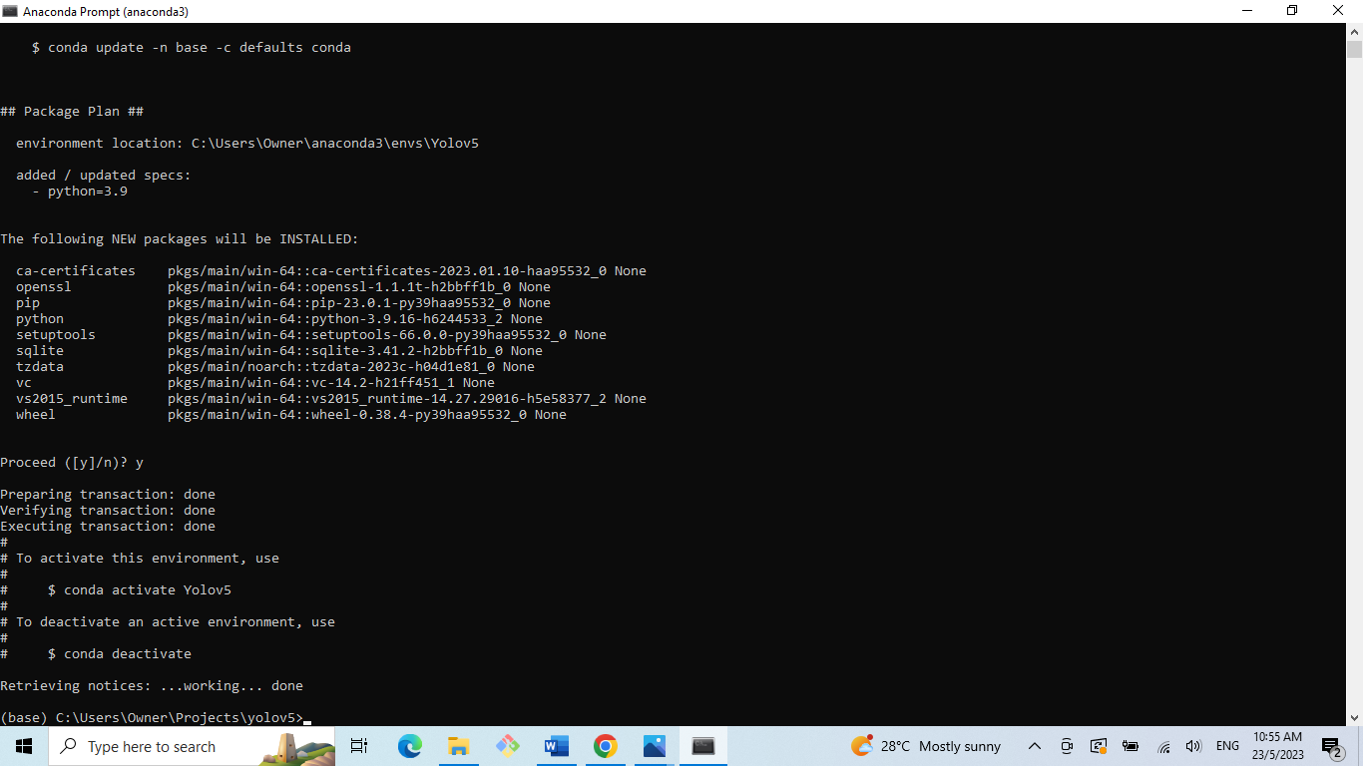

1. Activate the environment by running conda activate Yolov5

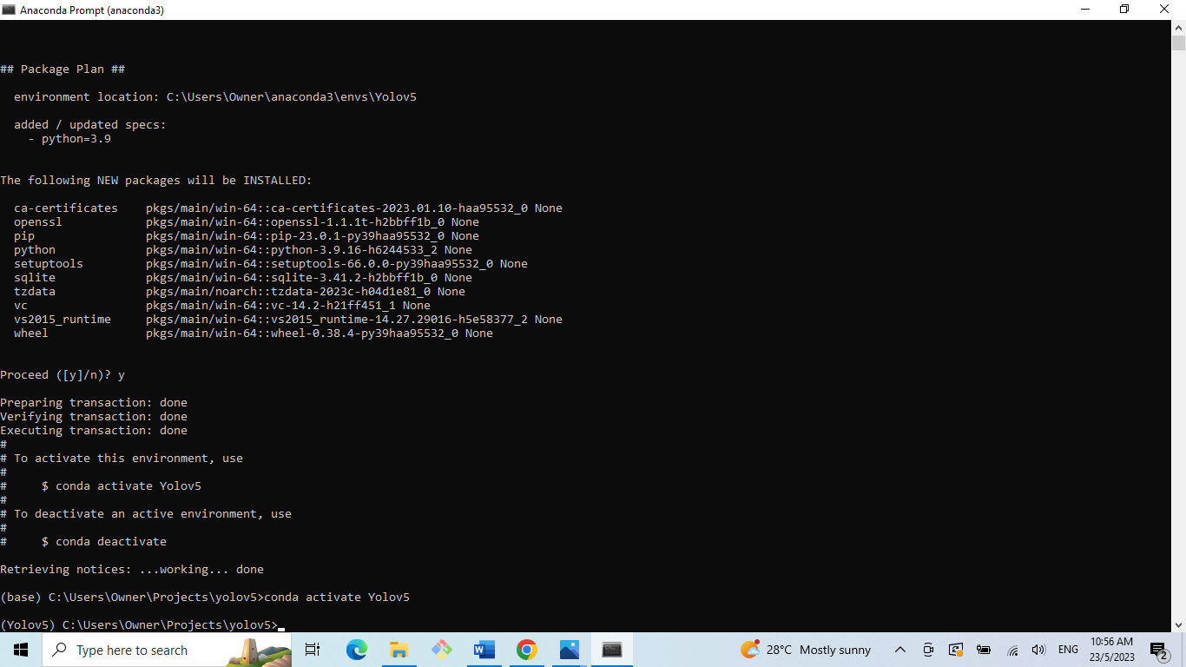

1. Download all the requirements

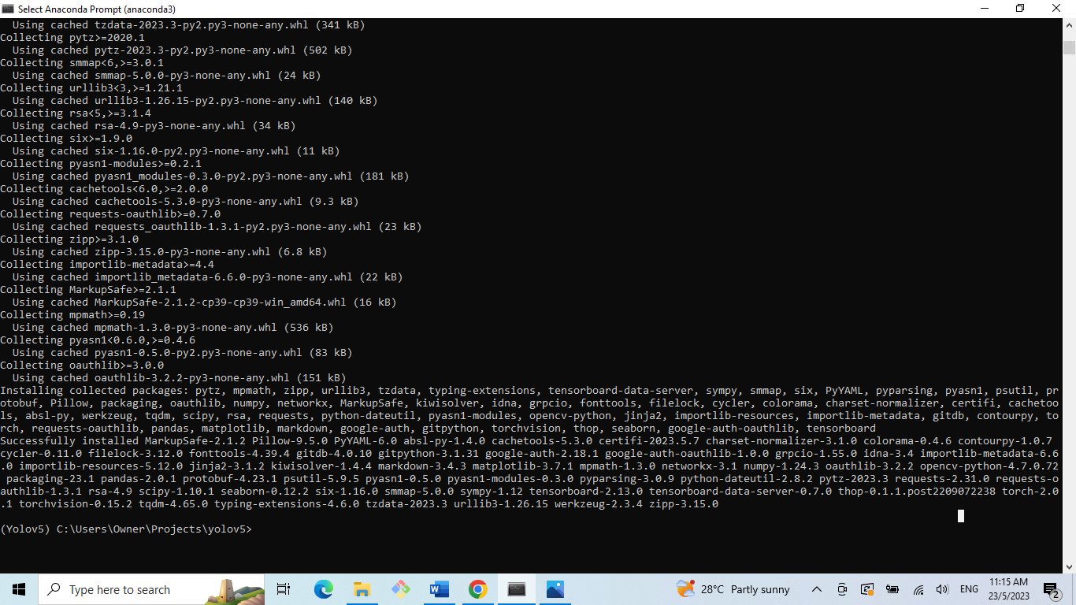

1. Run python detect.py –source 0

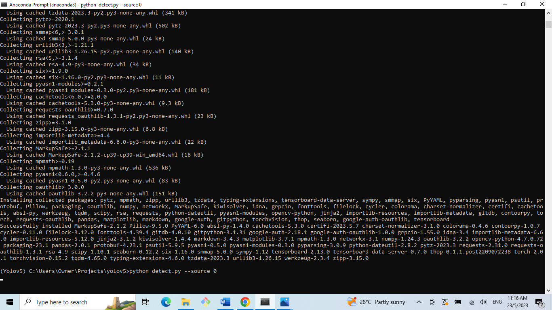

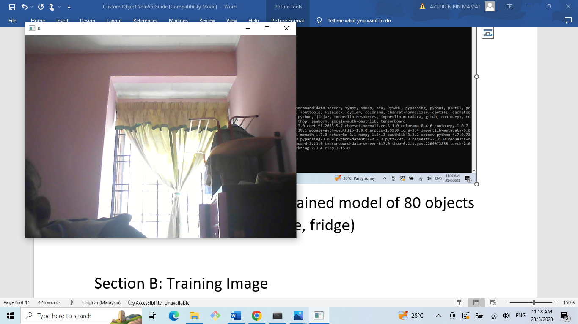

This will open a new window that shows the view of webcam. User now can run and view trained model of 80 objects of COCO dataset (Example: tie, fridge)

Section B: Training Image

**Collect and Label Images**

1. Use Roboflow to create a new project and upload your images. (Screenshot may be needed)

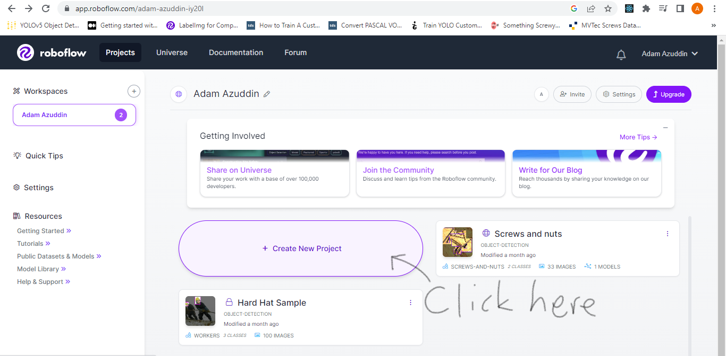

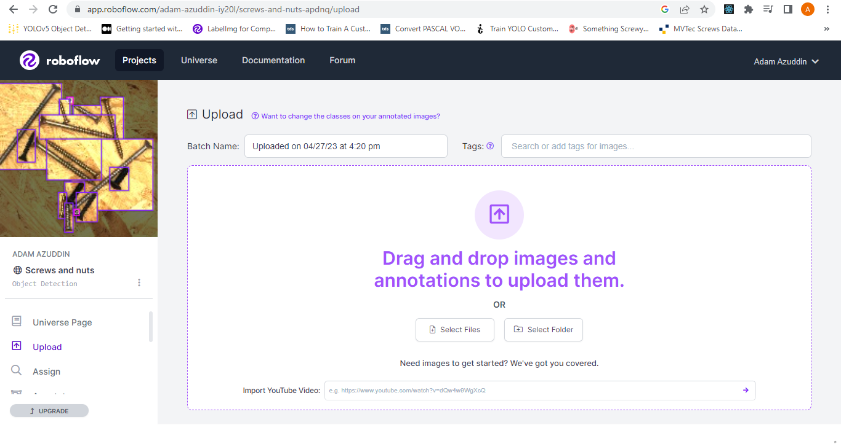

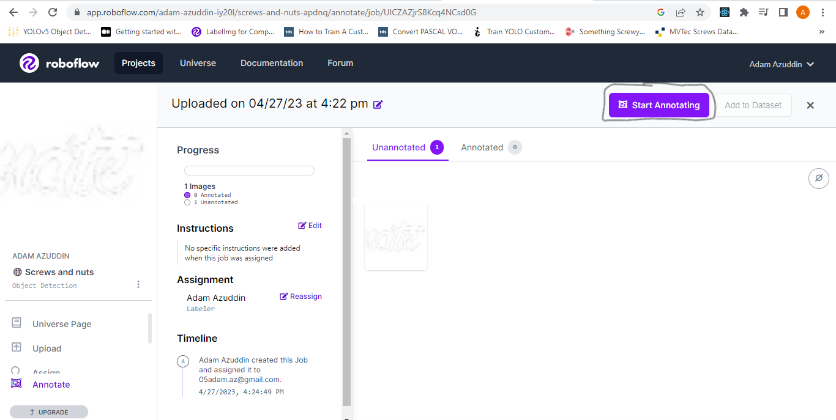

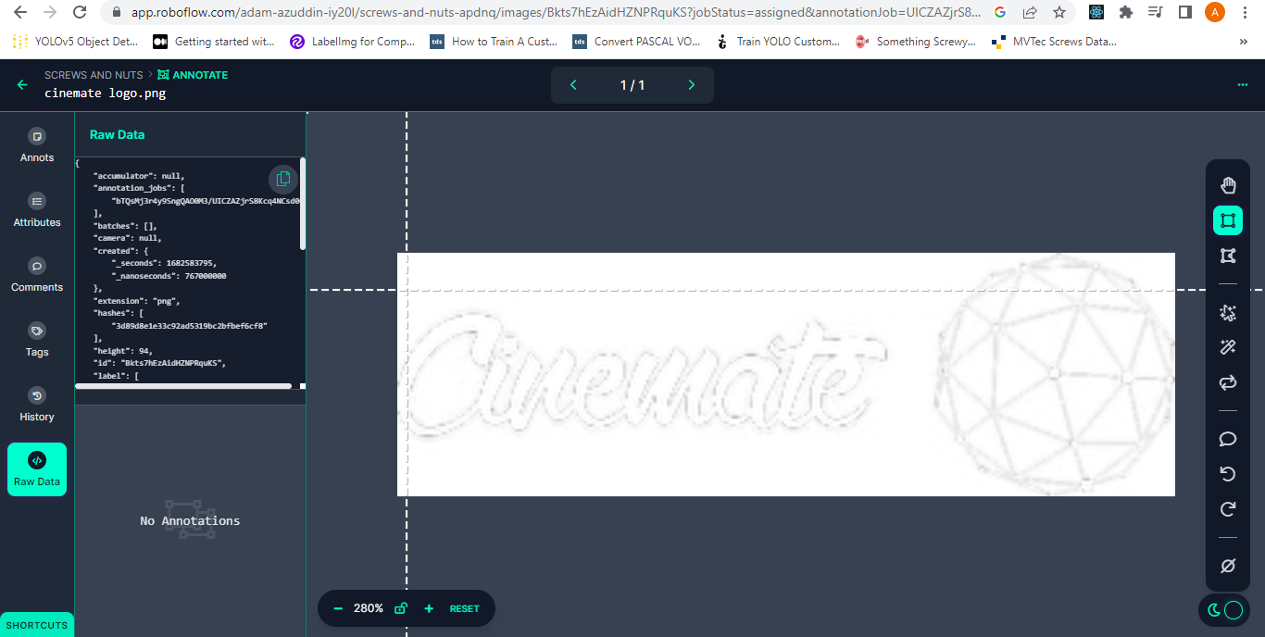

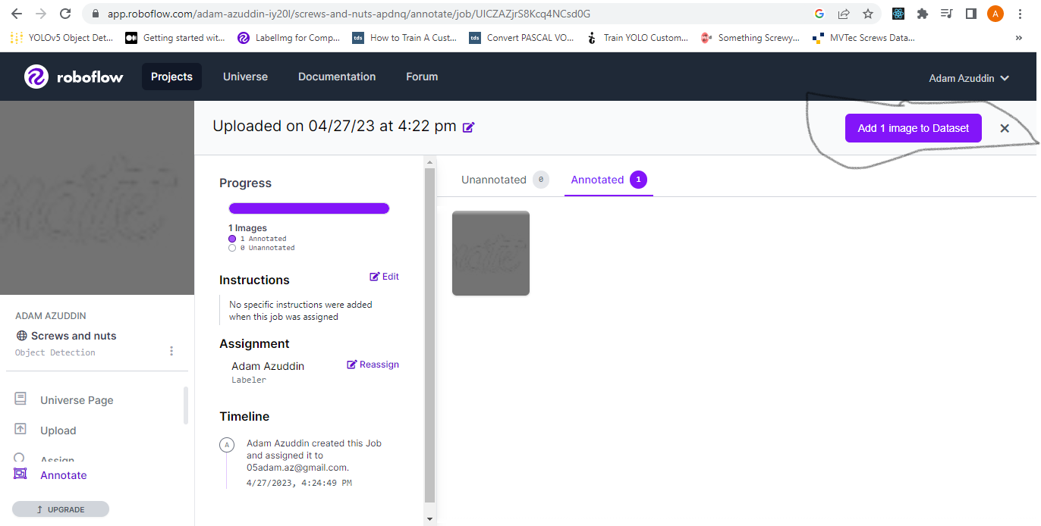

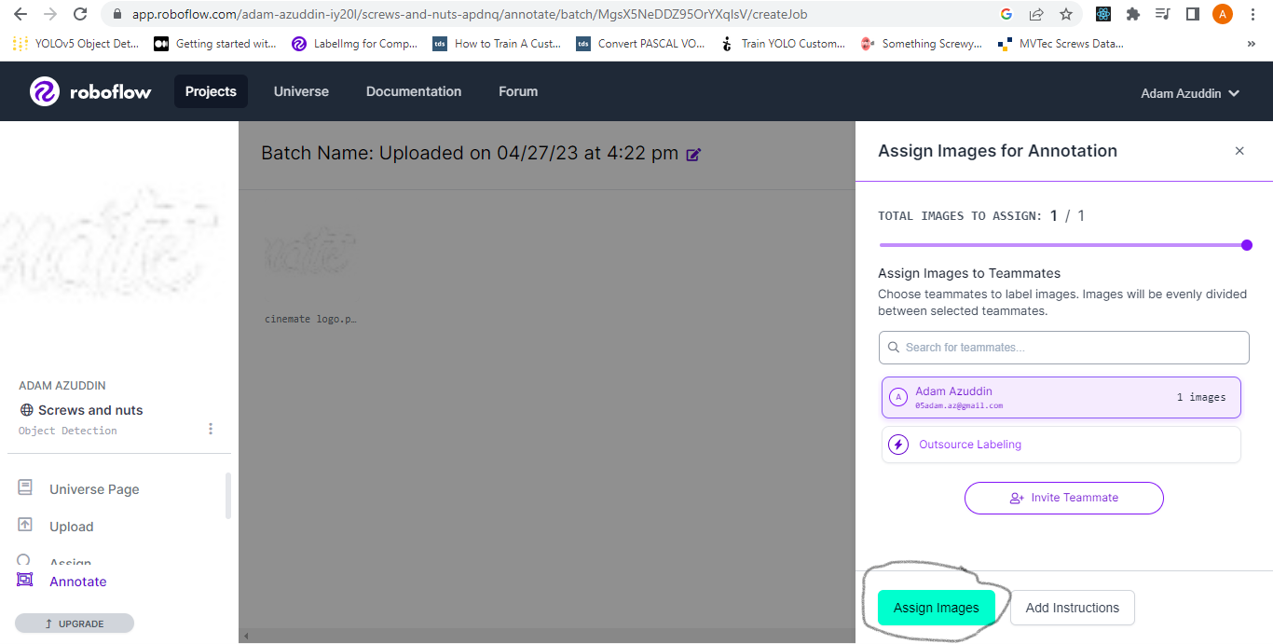

1. Label your images and train them. (Screenshot may be needed)
2. Export the dataset as YOLOv5 format and show the download code in a Jupyter notebook link. Copy that link. (Screenshot may be needed)

**Section C: Train the Model**

1. Open <https://colab.research.google.com/github/roboflow-ai/notebooks/blob/main/notebooks/train-yolov5-object-detection-on-custom-data.ipynb#scrollTo=FYSXiR35rCDU>.
2. Follow the code and run it. * Select file…
3. In code block number 4, paste the copied link of your Roboflow image dataset:

cssCopy code

# Follow the link below to get your download code from Roboflow !pip install -q roboflow from roboflow import Roboflow

1. In code block number 5, paste the copied link of your Roboflow image dataset. (Screenshot may be needed)
2. Run the code blocks sequentially until you reach code block number 11. The model will be trained.

**Download the Model**

1. Go to the files on the left sidebar. (Screenshot may be needed)
2. Navigate to **yolov5/runs/train/yolov5s_results/weights/best.pt**. (Screenshot may be needed)
3. Download **best.pt**. (Screenshot may be needed)
4. Navigate to **yolov5/your-roboflow-project-name/data.yaml**. (Screenshot may be needed)
5. Download **data.yaml**. (Screenshot may be needed)

**Edit detect.py**

1. Open **detect.py**.
2. Paste **best.pt**.
3. Search for **yolov5s.pt**, and replace it with **best.pt**.
4. Paste **data.yaml** in **data/data.yaml**. (Screenshot may be needed)
5. Replace the **data** variable in the **run** function like this: **data=ROOT / 'data/data.yaml'**.

**Test**

1. Open Anaconda.
2. Run **activate yolov5**.
3. Run **python detect.py --source 0**.
4. You're done!